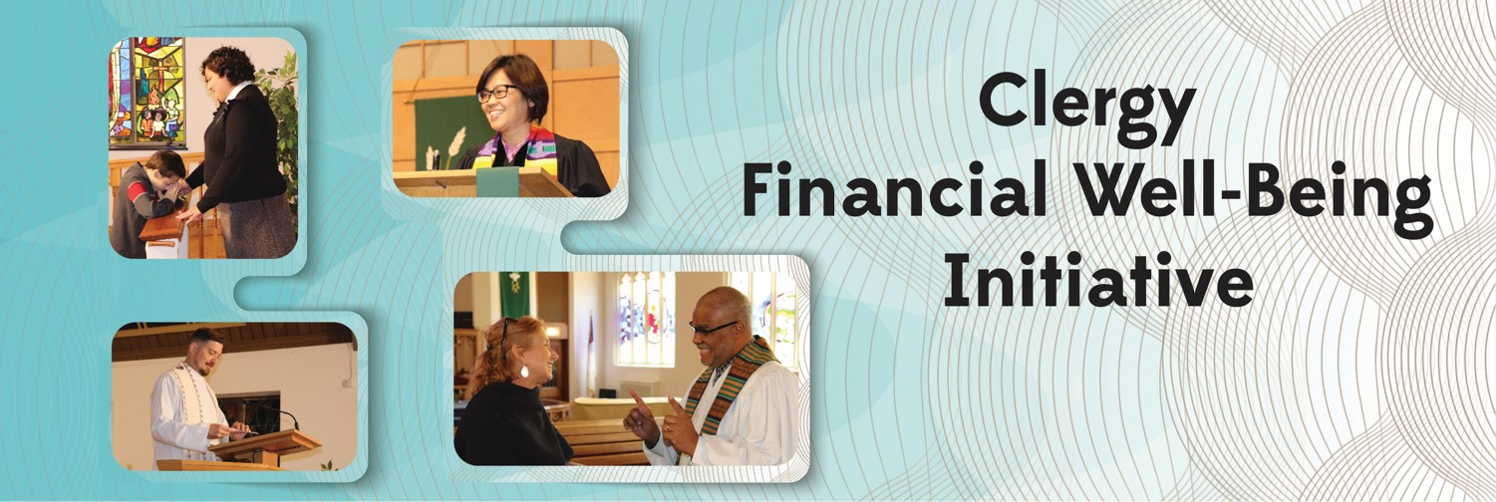

Project Application and Interest Form
Please use this form to apply for matching funds to deploy a project or other effort to improve clergy financial literacy and well-being for clergy harshly affected by the COVID-19 pandemic, especially underserved, under-resourced clergy.

Matching funds awarded to projects through this Initiative come from a Lilly Endowment Inc. grant made to Wespath Benefits and Investments. The Lilly Endowment’s grant “seeks to assist participating organizations in responding more directly and fully to critical economic challenges faced by pastoral leaders who are most harshly affected by the COVID-19 pandemic as well as to extend the reach of their programs to pastors who are currently underrepresented in their programs and have had limited access to their resources.” Wespath’s proposal for implementing this phase of the Initiative focuses on clergy of color and other clergy groups often underrepresented in United Methodist programs and activities for clergy support and financial well-being.

Additional background about the Clergy Financial Well-Being Initiative and information about the latest phase of the Initiative focused on underserved and pandemic-impacted clergy is available in this press release:
https://www.wespath.org/News/PR-12-20-21#!/page:1.

General Information about Applying for Matching Funds from the Initiative
- Projects should seek to improve the financial well-being of underserved and pandemic-impacted clergy, in accordance with the objectives and focus described above.
- Matching funds awards from the Initiative can fund up to one-half of project costs.
- Per stipulations from Lilly Endowment Inc., “In-kind donations are not eligible for the match.” Accordingly, only actual expenditures for the project or effort are eligible for matching fund awards. Value or cost of the time, skills, or labor of the applying organization’s staff does not qualify for matching funding.
- Amounts of matching funds awards may be influenced by the number of pastors or congregations participating, the expected impact on participants, and the follow-up and ongoing assessment, among other factors.
- Funds are limited and will be awarded as applications are received and approved for funding, until available monies have been committed.
- To support reporting obligations to the Lilly Endowment, grant recipients will be required to report to the Clergy Financial Well-Being Initiative on use of funds awarded, outcomes from the project, number of clergy, and if applicable, number of laypersons and congregations reached by the project. These reports should be directed to Initiative Project Manager Bonnie Marden, clergyfinance@wespath.org.

To Receive Additional Information:
- Please contact me—I would like to talk further about the Initiative.
Name ________________________________ Position _____________________________________
Best contact options (phone/e-mail) ____________________________________________________

- Please add me to future e-mail Initiative communications. ______________________________(e-mail)

Project Description
Attach pages for items 1) through 3):
1) Describe your idea or project model selected. Include time frame (anticipated dates and amount of time), educational content and delivery method, and the target audience.
2) Identify partners participating in the design and implementation of this project.
3) Describe the measurable outcomes and expectations for participants. Explain any plans for follow up and ongoing support and/or tracking (for reporting, assessing progress, and accountability).
4) Indicate below or in an attachment the projected total cost of the project and the monetary contributions of all partners, including the Clergy Financial Well-Being Initiative request (which can be up to 1/2 of total costs). Expand chart as needed.

Expense Items and Funding Sources

1.
2.
3.
4.
Funding Sources Total
1.
2.
3.
- Total Project Expenses (all partners cash contributions)
- Initiative Support Amount Requested
- Organization and Partners’ Financial Responsibility

5) Contact information (Name, e-mail, phone) for leaders or partners for this project.

Name: ___________________ E-mail: ____________________ Phone: _______

Name: ___________________ E-mail: ____________________ Phone: _______
Name: ___________________ E-mail: ____________________ Phone: _______
.
Submit application to and attachments along with any additional project documentation to clergyfinance@wespath.org.

Interested parties are encouraged to initiate this process with a conversation with Project Manager
Bonnie Marden (clergyfinance@wespath.org) or 978-846-1260.

