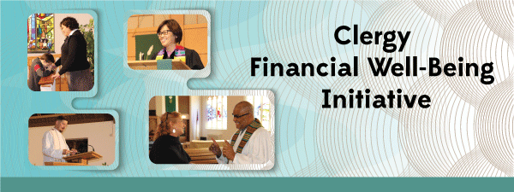
Saving Grace Resources and Incentives
Funding Opportunity


Proposals: Application form (see below) requests project description, timing, delivery method,
target population and summary of costs/budget that shows realistic planning has occurred.
There is no matching requirement, but applicants should demonstrate awareness of
administrative tasks and costs (registration, facilitation, partners, etc.).
Use of Funds: Funding can be used to reduce costs of materials or to incentivize participation in this study, or to incentivize activities related to financial well-being such as paying down debt, creating savings, retirement funding or working with an EY financial counselor (available to Wespath clients at no cost). Incentives are limited to $300 per person/family unit.

Evaluation: To support and evaluate this resource, recipients are encouraged to participant in a feedback/evaluation process which may include a report and online survey for participants. Participant testimonials in written or video format are also appreciated.

Saving Grace - Request for Funding
United Methodist entities may request funding for Saving Grace materials and incentives for financial well-being activities by Saving Grace cohort participants such as paying down debt, creating savings, retirement funding or working with an EY financial counselor (available to Wespath clients at no cost). Clergy cohorts are preferred.
1. Name of Contact Person
2. Organization
3. Phone and Email Address
4. Project Description: Briefly describe what you want to do, your target audience and timing.
5. Provide a description of your costs, other funding sources or in-kind contribution to show the resources that will contribute to your success.

6. ____ We agree to submit a report about our experience and results (by online survey for participants and leadership). We will invite testimonials in written or video format including permission to use in other educational or promotional activities.

This proposal is submitted with signatures from two project leaders or partners such as project leader, facilitator, financial officer, pastor or lay leader.
Signature 1______________________________ Title _______________________________

Signature 2 _____________________________ Title _______________________________
Submit to: clergyfinance@wespath.org

