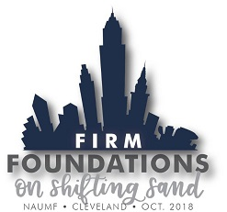

October 22 – 24, 2018

Cleveland Marriott Downtown at Key Center

Cleveland, Ohio

Event and Registration Information

Register Now!

Participant Early-Bird Registration Fee - $425.00 by August 3 ($475 after August 3)
Spouse Early-Bird Registration Fee - $250 by August 3 ($275 after August 3)
Registration Deadline – September 28

The registration fee includes:

- Welcome reception and dinner on Monday
- Breakfast and lunch on Tuesday
- Breakfast and lunch on Wednesday
- Opening Reception and refreshment breaks
- Event materials

The annual NAUMF Meeting begins at 8:30 a.m. on Tuesday, October 23 with inspiring opening worship by Bishop Sandra Steiner Ball. The meeting concludes on Wednesday, October 24 following the afternoon presentations.

A Night to Rock and Remember!

Rock and Roll Hall of Fame - $80
Wednesday, October 24 – 5:00 p.m. – 9:00 p.m.

The Rock and Roll Hall of Fame, located on the shore of Lake Erie in downtown Cleveland, Ohio, recognizes and archives the history of the best-known and most influential artists, producers, engineers and other notable figures that have had a major influence on the development of rock and roll.

Join in for an evening of great food, fellowship and exploration as you rediscover lost artists and learn about some of your current favorites!

Hotel and Travel Information

Host Hotel:

Cleveland Marriott Downtown at Key Center

127 Public Square

Cleveland, Ohio 44114

Phone number: 216-696-9200
NAUMF has a negotiated special room rate of $164 plus tax

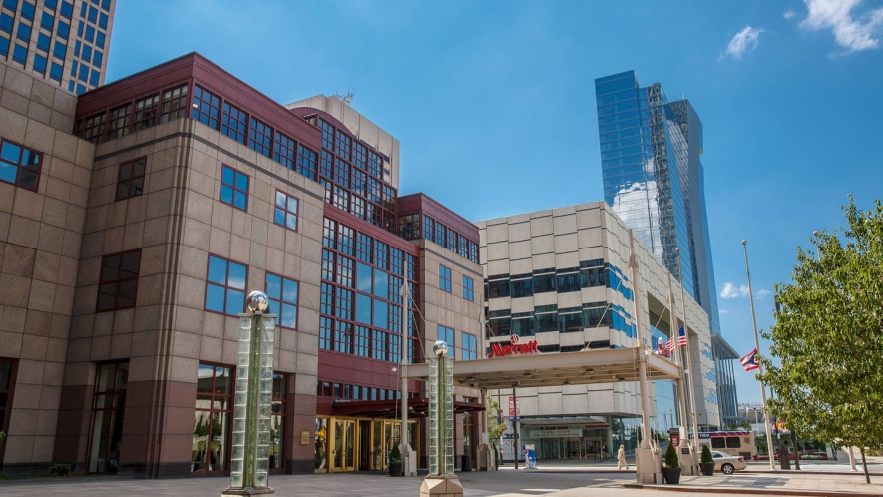

In order to make a reservation at the hotel, please click here - Cleveland Marriott Downtown at Key Center Reservations. If you prefer to call, you may call 888-236-2427 and mention the group rate ‘NAUMF’ for the discounted rate.

* Please note, any rooms required outside of the meeting dates, are based on availability and could be at a higher rate.

Travel Information

The closest airport to this event is Cleveland Hopkins International Airport (CLE). The airport is approximately 12 miles from the host hotel. A taxi will cost approximately $30 one-way; an UberX is approximately $25 each way. Depending on traffic, driving from the airport could take anywhere from 15 minutes to 30 minutes.

The most economical/efficient way to get downtown from the airport would be taking the Regional Transportation Authority’s ‘Red Line’ train. The cost of this train is $2.50 one-way. This 35 minute train ride will take you into Tower City Center. From Tower City Center, you can take a short walk to the hotel (less than 5 minutes). Info on the train can be found here - Greater Cleveland Regional Transit Authority

Optional Spouse Activities

Two Faces of Cleveland - $60

Tuesday, October 23 – 8:30 a.m. – 3:30 p.m.

While Cleveland has one of the highest poverty rates in the United States it also has a rich arts scene. We’ll tackle both of these in one day. The Nehemiah Mission and the Free Store are two Cleveland-based United Methodist outreach programs working in the Gordon Square Neighborhood. There will be time to do some volunteering and learning about how the church is at work in this community and throughout Greater Cleveland. Then it’s off to lunch at the Hermit Club, a 115-year-old private club committed to the performing arts and now part of the HofbrauHaus. The highlight will be a backstage tour of Playhouse Square, the largest live performing arts complex outside of New York City. Its seven theaters and nearly 100-year history make for a fascinating tale of show business, near misses and an incredible vision to bring all of it back to bygone glory. See for yourself the largest theater restoration in the history of the United States.

University Circle Tour – Free
Wednesday, October 24 – 10:00 a.m. – 3:30 p.m.

Cleveland’s University Circle boasts 10 museums, a half-dozen music performance spaces and acres of parks. We’ll hop the Rapid Train from Terminal Tower to the Circle where we will enjoy unstructured time to explore the area as you wish, with lunch on your own in any of the dining areas in the museums or elsewhere in the area. Imagine a day when you can see a Picasso, a Monet, the heroic dog Balto, a butterfly release and so much more.
A University ‘Circle Pass’ can be purchased which gives you discounted admission to four of the museums. More information on the Circle Pass can be found here – Circle Pass Information
There is no charge for the day’s activities; however, the Rapid Train ticket, lunch and museum admission are the responsibility of the attendee.

Optional Thursday Activity

A trip to Amish Country - $75
Thursday, October 25 – 8:30 a.m. – 5:30 p.m.

While our meeting is in the tallest building between New York and Chicago we are just 60 miles from the heart of the largest Amish population in the country. On this all-day tour we’ll immerse ourselves into a culture without electricity, motorized vehicles and the internet. We’ll start at Lehman’s Hardware Store, which still sells tools and housewares used every day on Amish farms, enjoy lunch in an Amish home and have a demonstration at a basket maker’s shop. Our final stop will be the Amish and Mennonite Heritage Center which features the Behalt Cylorama a nearly 300-foot-long mural depicting the history of the Amish faith. We will depart the hotel at 8:30 a.m. and return around dinner time. Cost includes the tours and lunch.

Questions

For questions about the program, please contact Tom Marston at 1-863-370-0951 or Email Tom

For questions about registration, travel, or hotel accommodations, please contacts Anne Green at 1-800-269-2244, ext. 4560 or Email Anne

